<https://www.superdatascience.com/learning-path>

<https://www.superdatascience.com/12>

https://www.superdatascience.com/data-visualization-training/

Data Set:

<https://www.superdatascience.com/pages/tableau>

<http://ude.my/UC-D2JPPAJN>

**How does Tableau know at which level to aggregate values?**



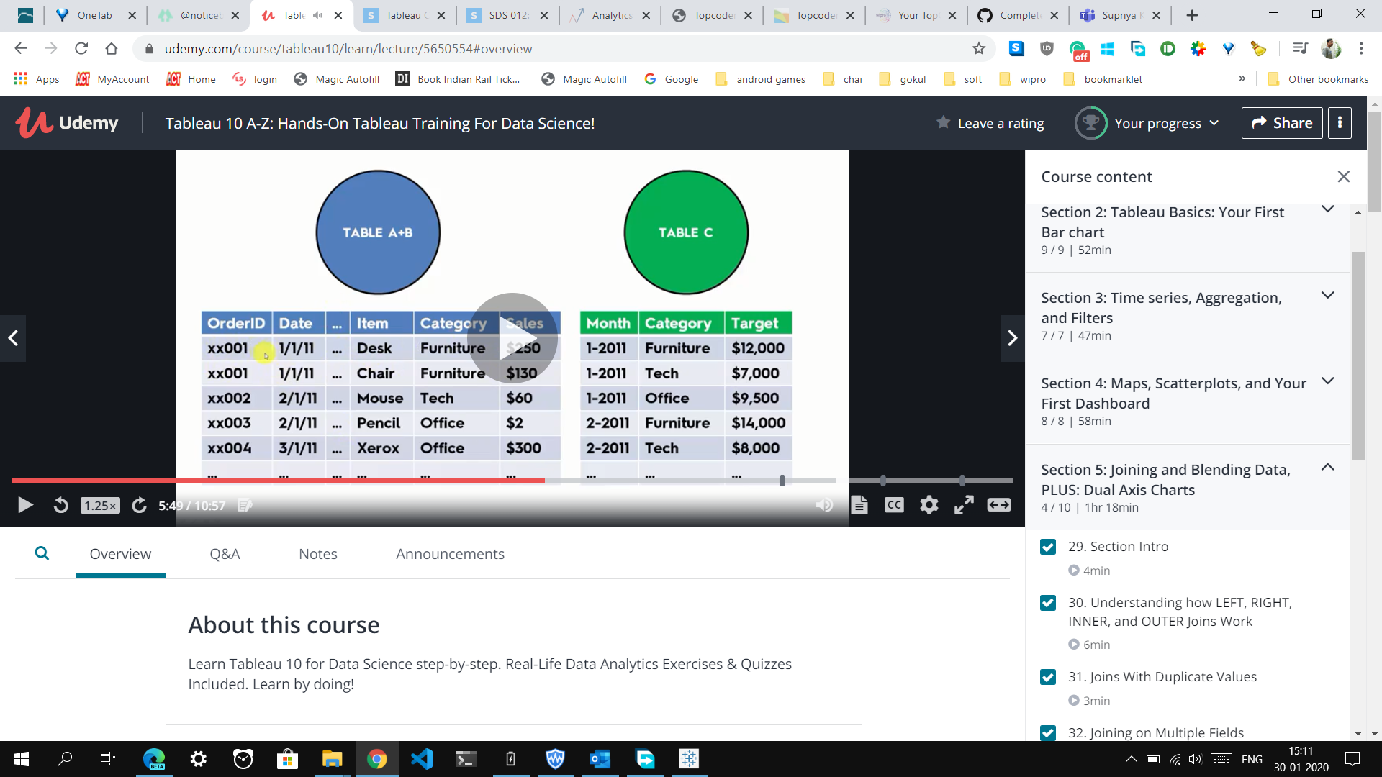

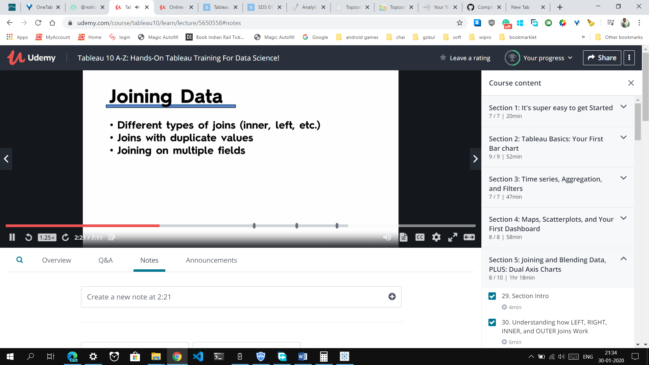

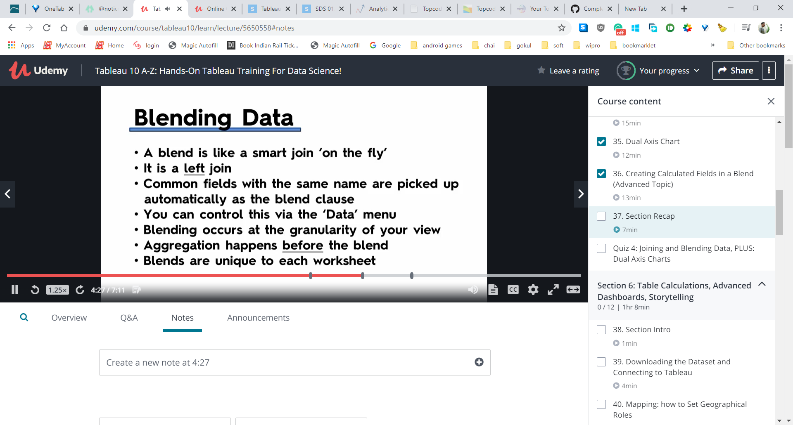

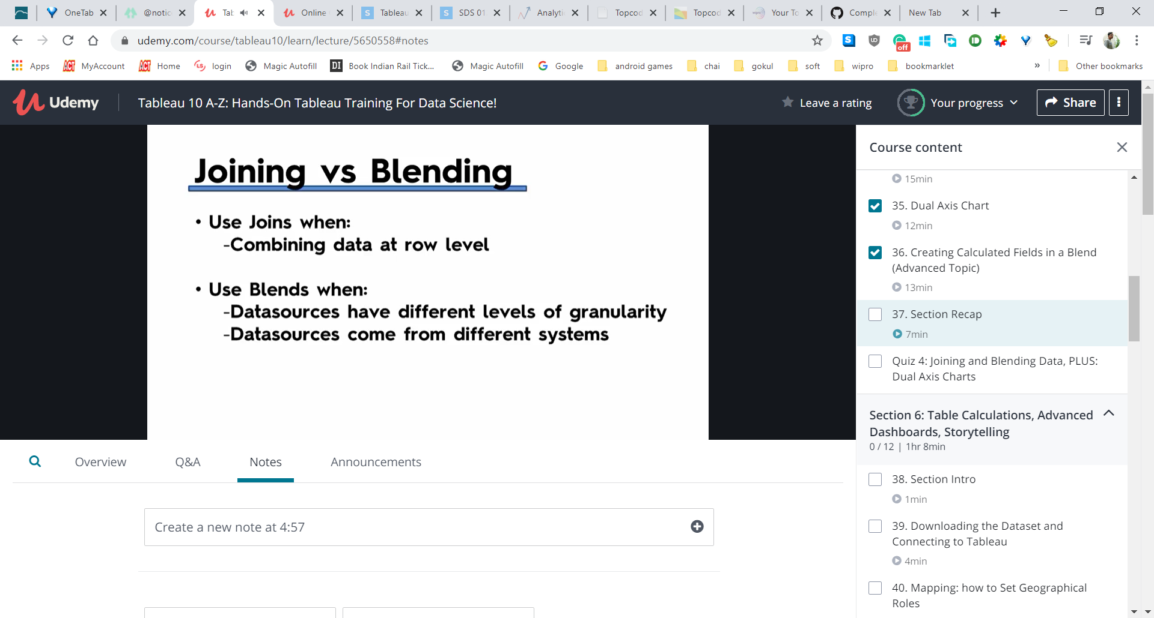

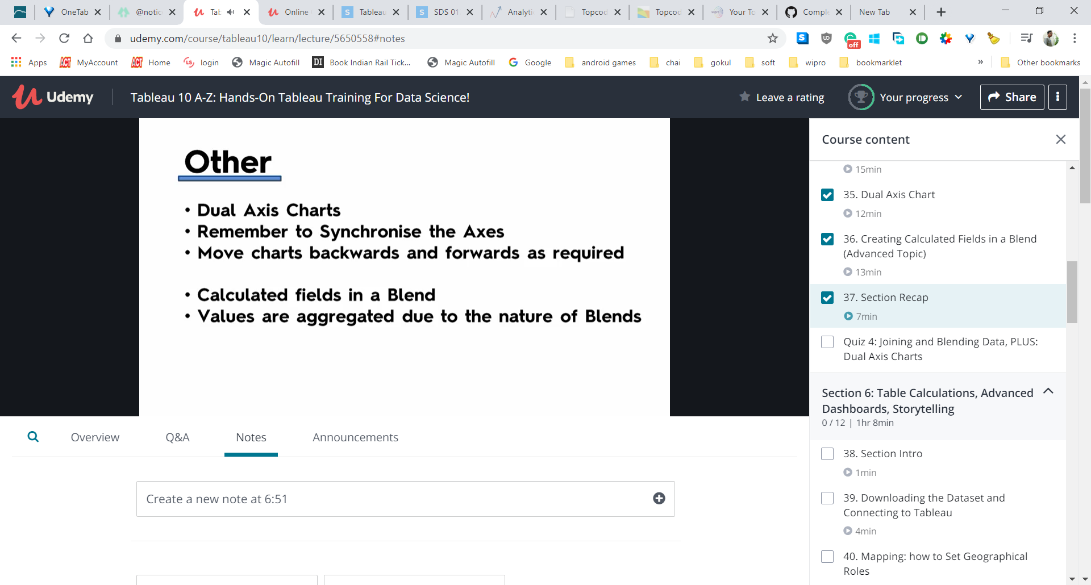

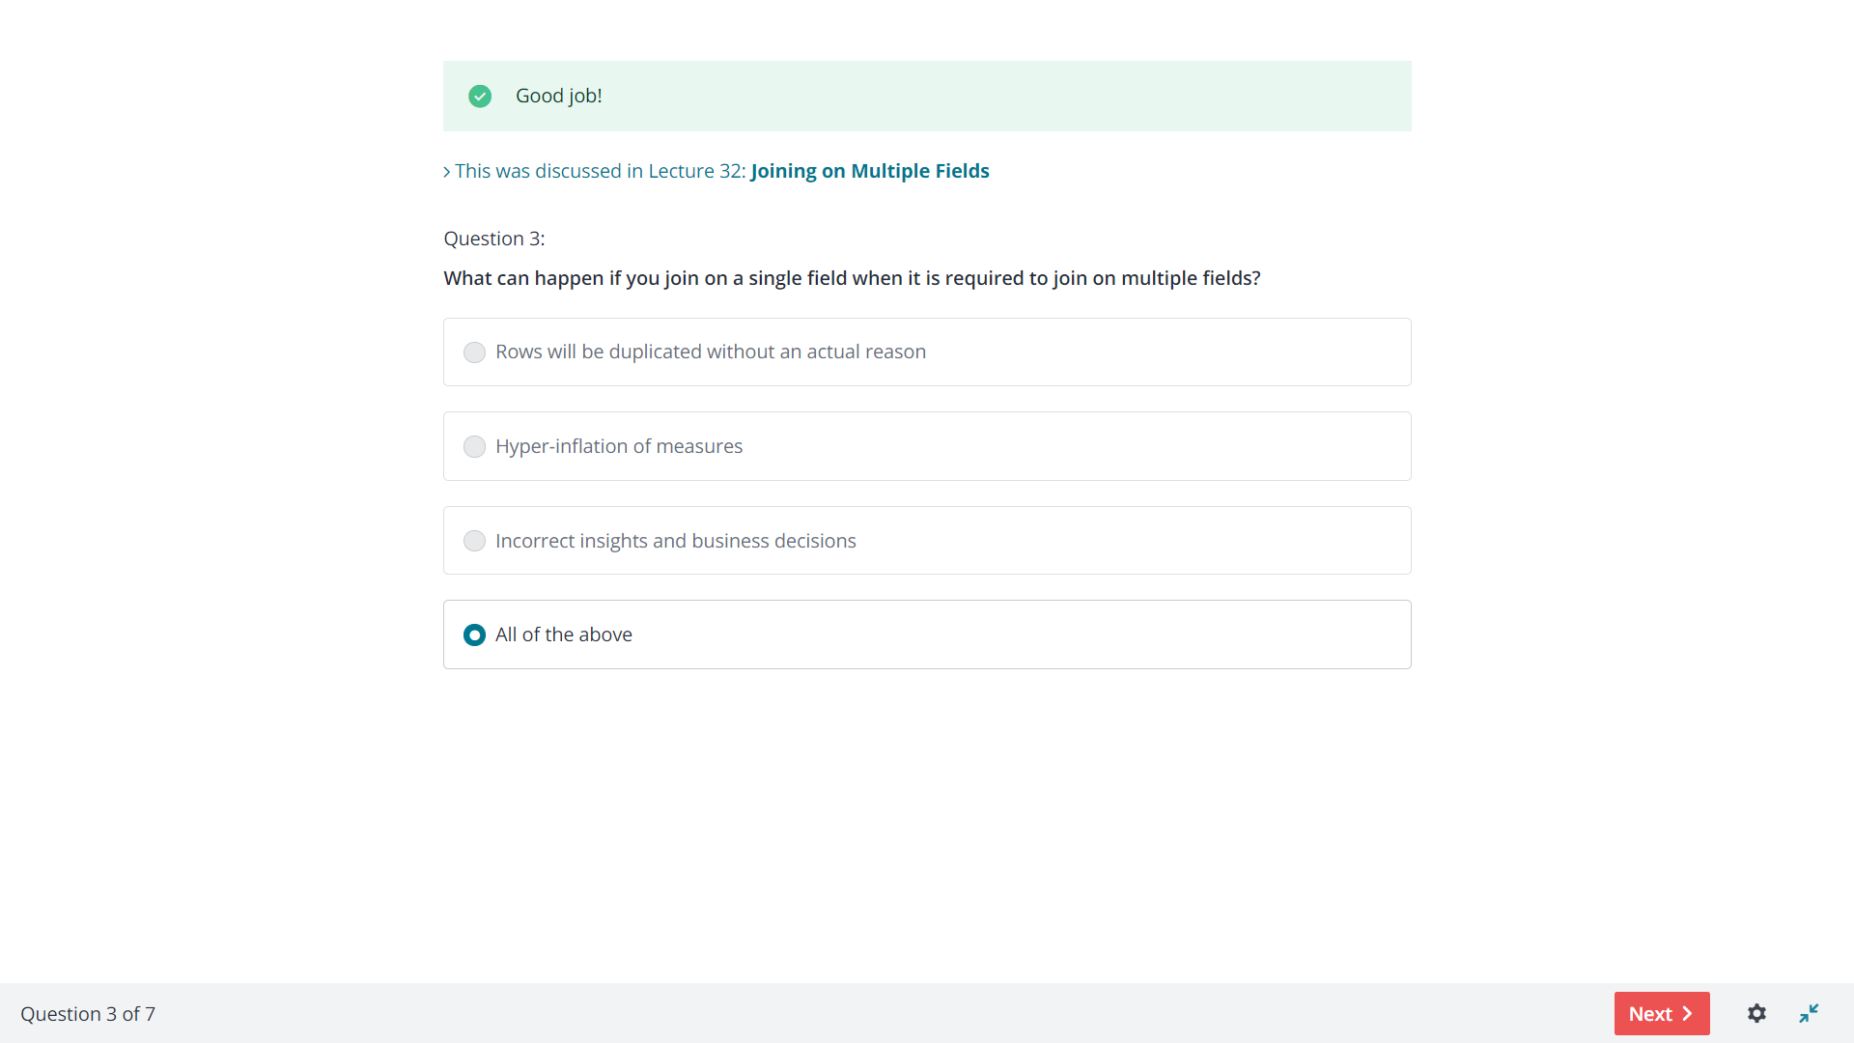

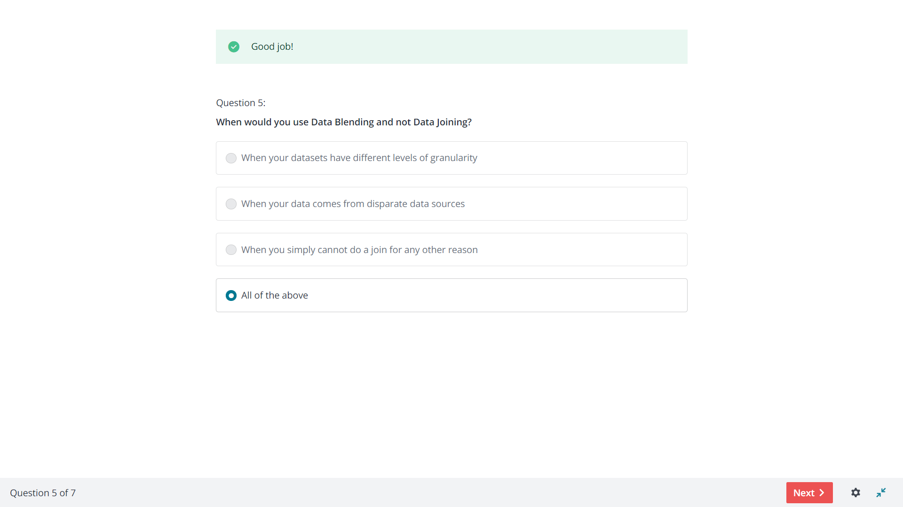

<https://data-flair.training/blogs/tableau-custom-territories/>

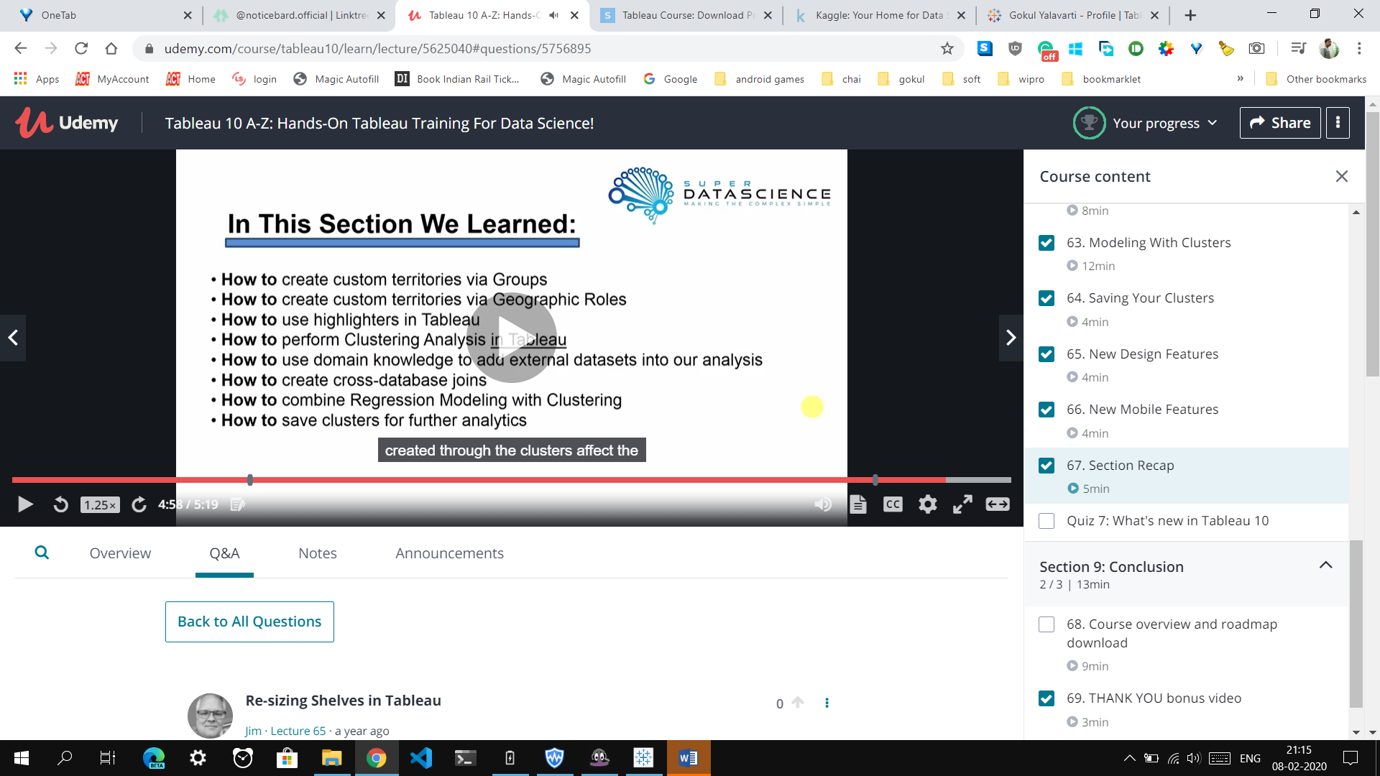

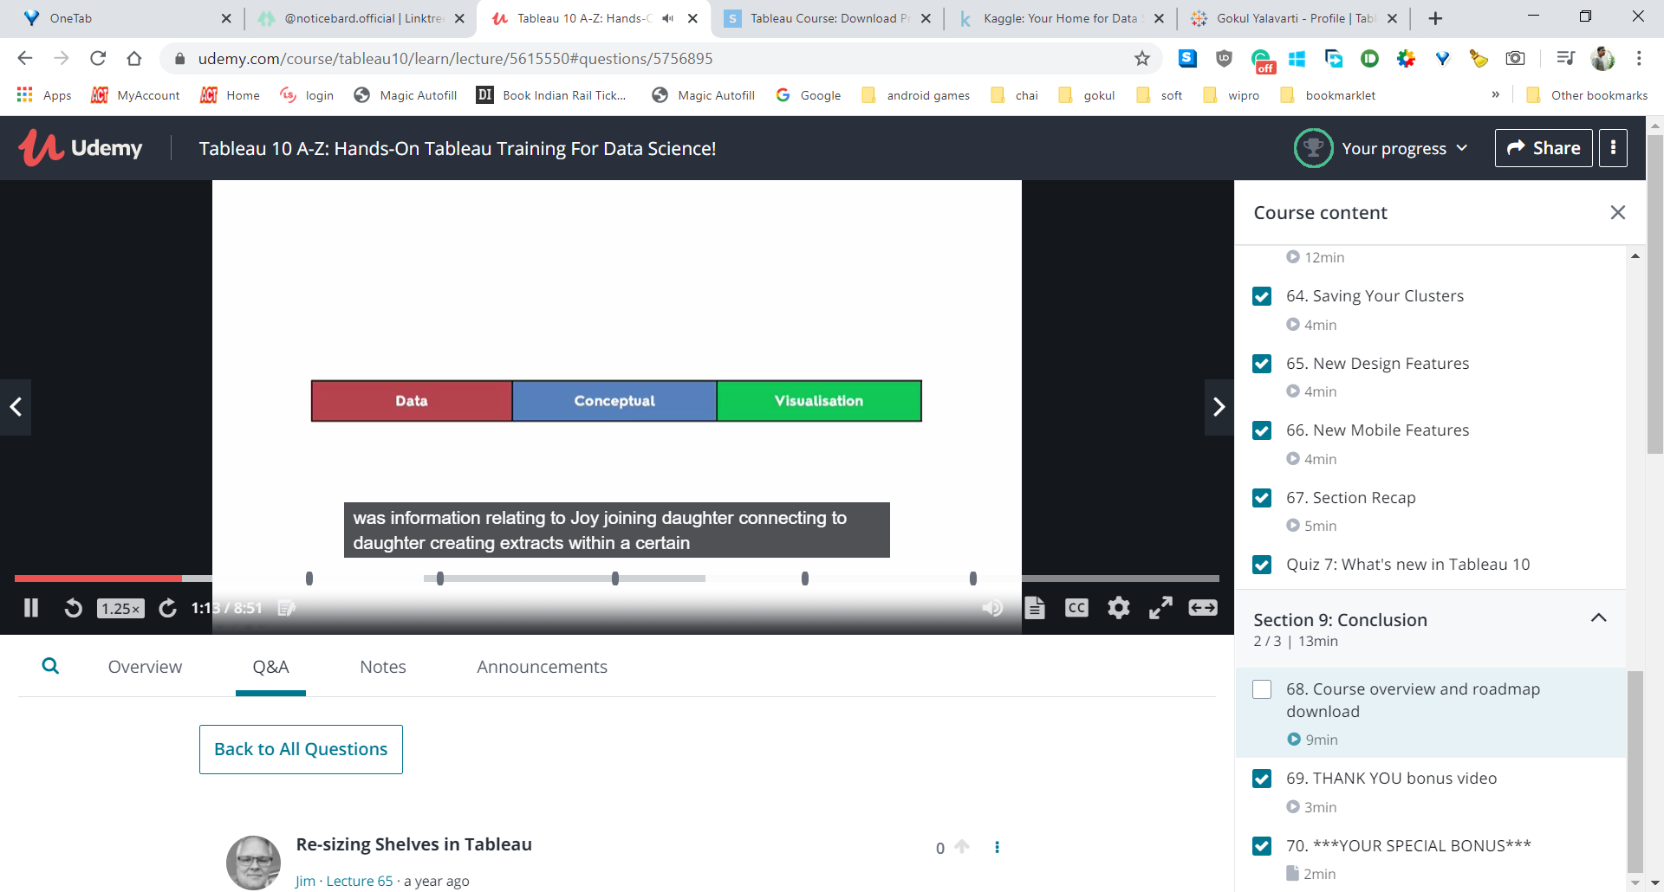













<https://www.udemy.com/certificate/UC-36046c43-66a6-4a5c-a249-089320a39e5b/>

Advanced:

**Section 2**

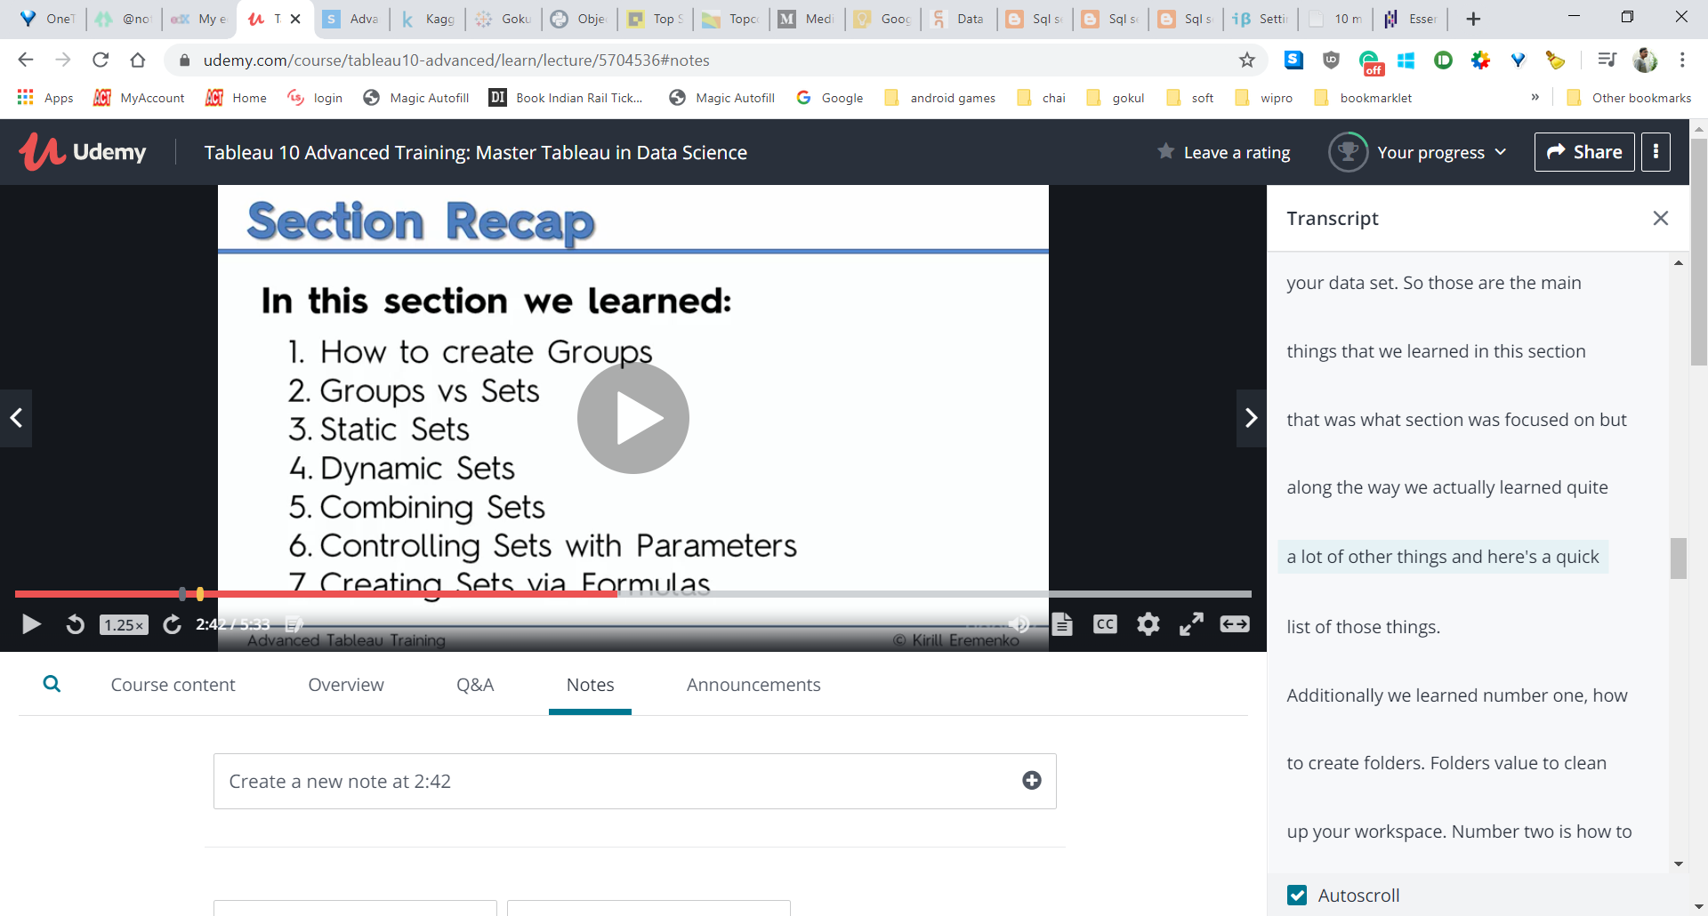

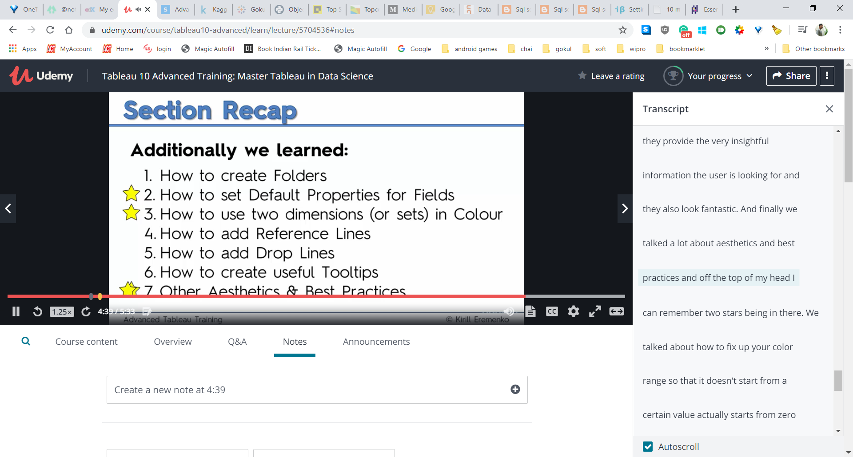

1. **You are combining two sets A and B into a third set C. Which of the following is NOT an option that you can select from when combining the sets.**



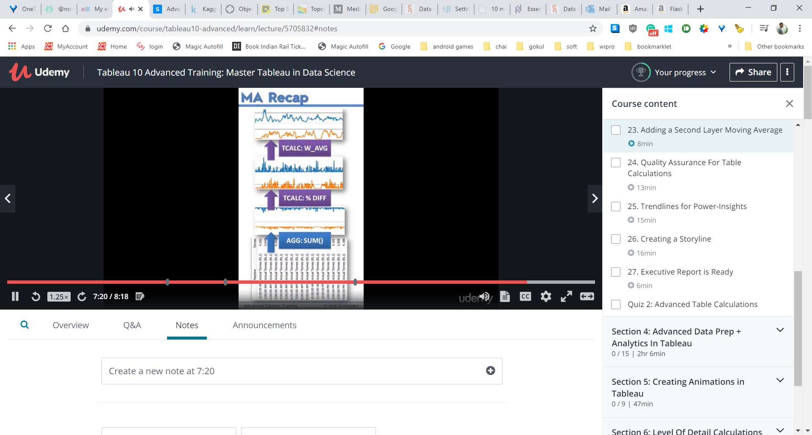

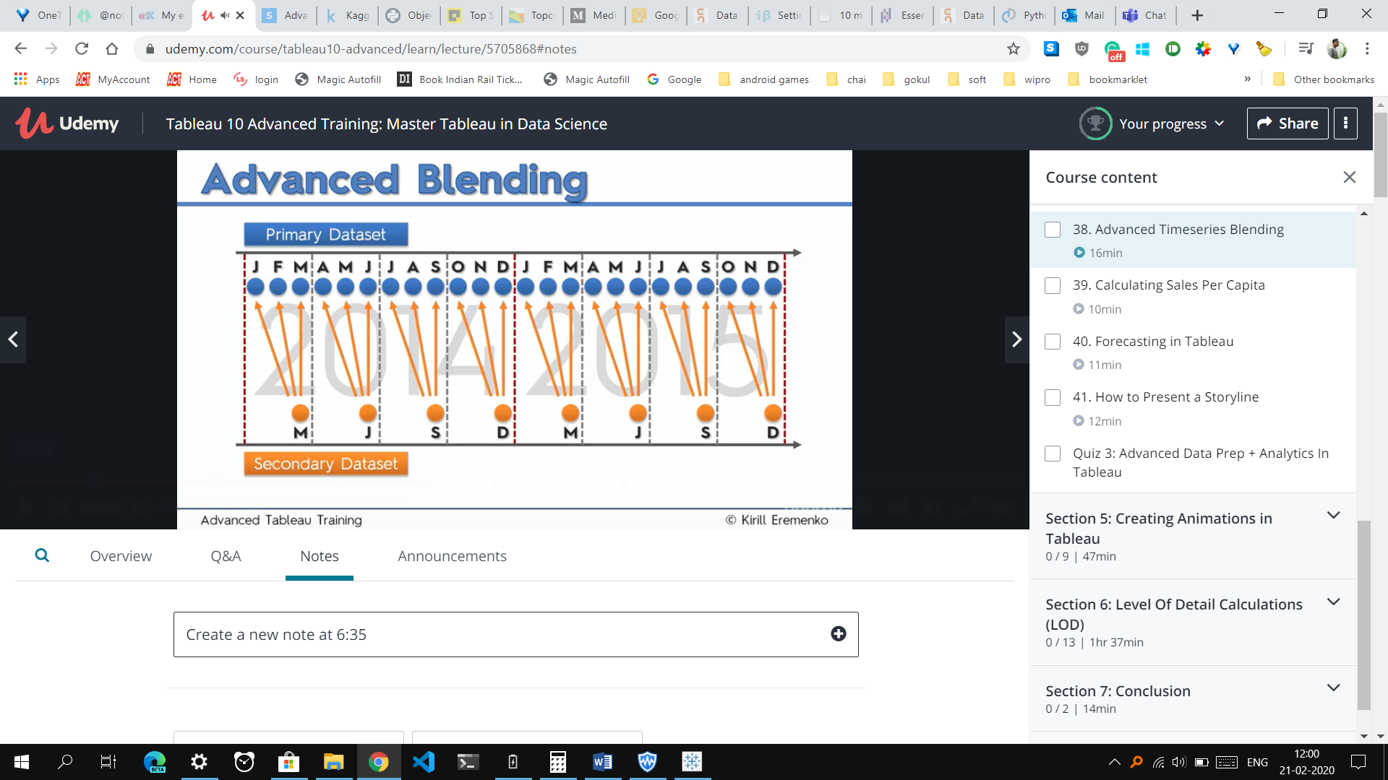

**Which of the following prediction intervals will be the widest in a Forecast?**

**99%**

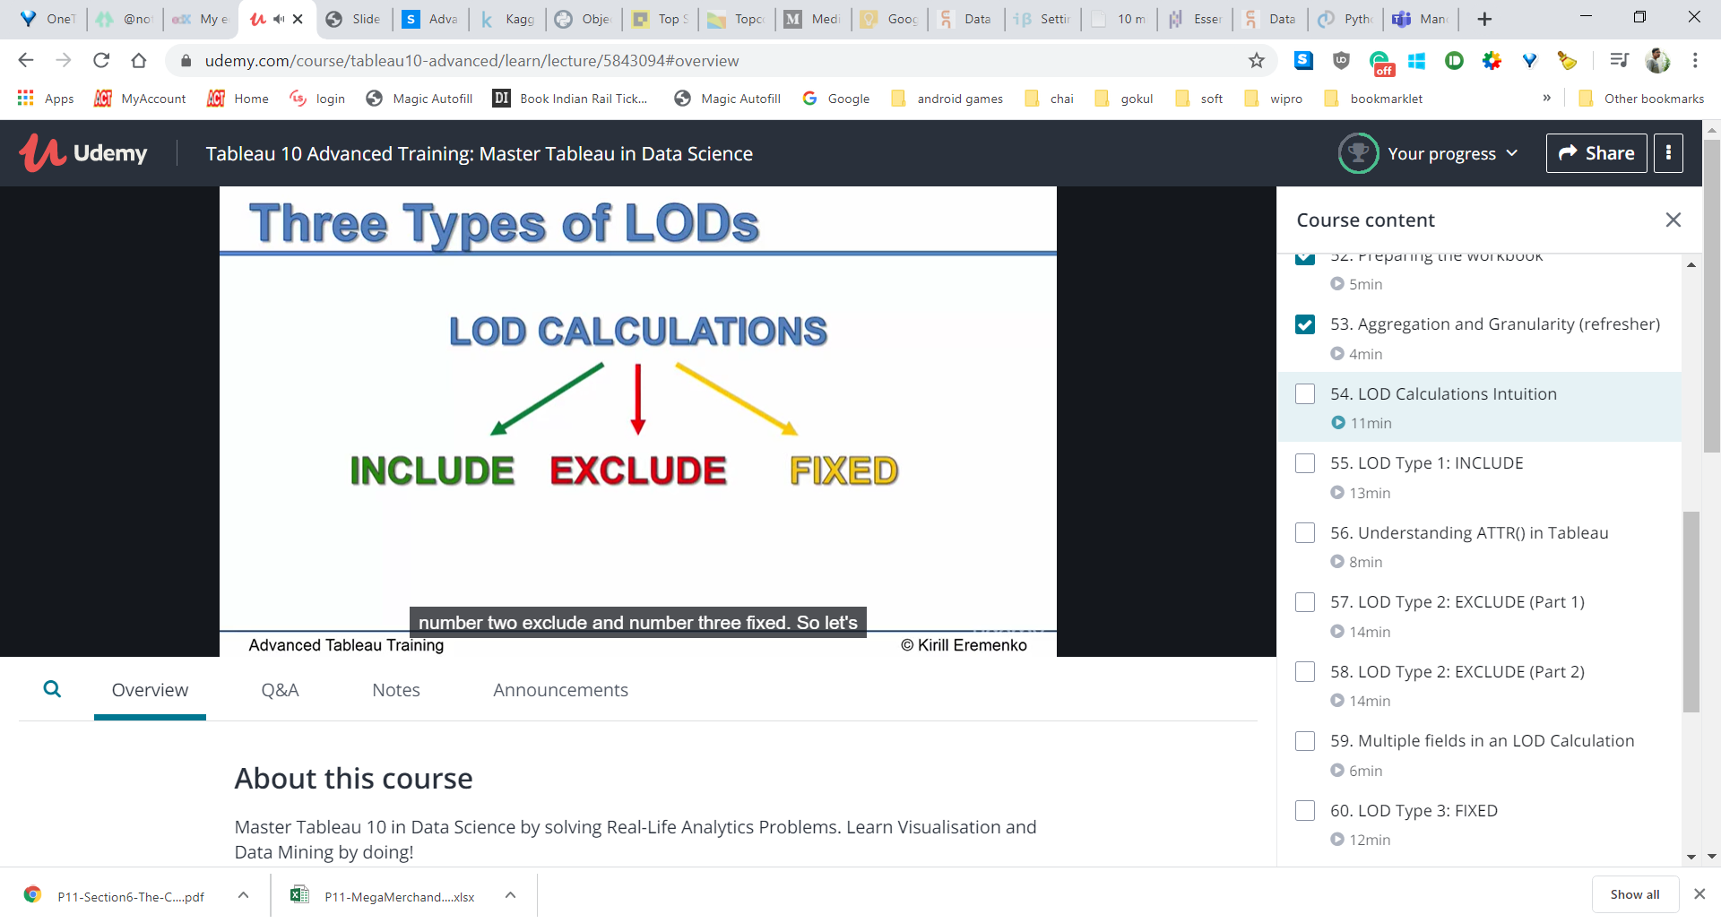

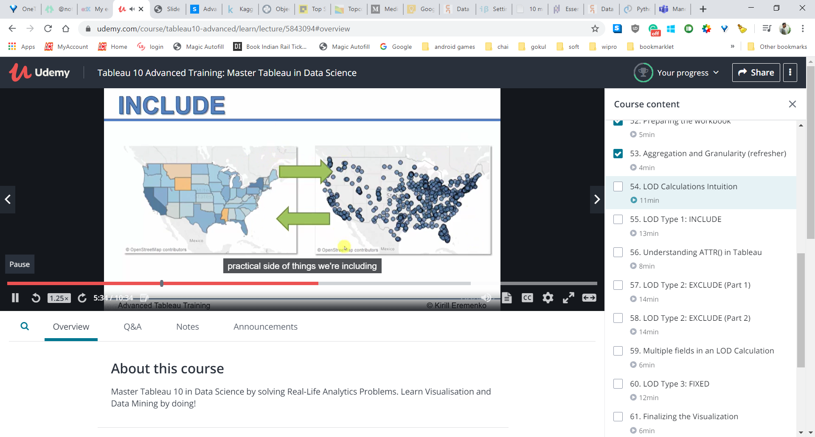

Exclude : If you're working at a level of aggregation such as city for instance in this case and then you need to for some reason go to a higher level of aggregation also you want to lower the granularity and you want to go to the state level but you don't want to change your visualization, you just want to get some data from some from so calculations at the state level and bring them back right? So then that's what exclude allows you to.

**Explanation LOD:**

your hard drive you know? So if you're if you're familiar with program programming then you can or basically any type of computer work you can always specify a relative or absolute path right? So include, exclude are relative paths so say your on folder x include means go intoa subfolder and find something in the sub folder so going to make the increase the granularity. Exclude means going to the parent folder of the current from your current location where is fixed is the absolute path. You don't fix doesn't mind where you are now your folder X or folder Y, you're in the parent folder or the child folder. Doesn't matter, if it fixes like specifying absolute path to your folder where you want to find something. That's kind of a very simplistic type of analogy but it does drive the point home.

For color : abs(sum([Profit])/attr([LOD Exclude - State Profit]))*sign(attr([LOD Exclude - State Profit]))

For size of circle: abs(sum([Profit])/attr([LOD Exclude - State Profit]))

60. LOD Type 3: FIXED

sum([Profit])/attr([LOD Fixed - State Profit])*sign(attr([LOD Fixed - State Profit]))

abs(sum([Profit])/attr([LOD Fixed - State Profit]))

**Which of the following statements is true when you add a new dimension to your visualization?**

Level of granularity increases, level of aggregation decreases

**Which of the following is the correct definition of the ATTR() function?**

Returns the value of the expression if it has a single value for all rows. Otherwise returns an asterisk. Null values are ignored.

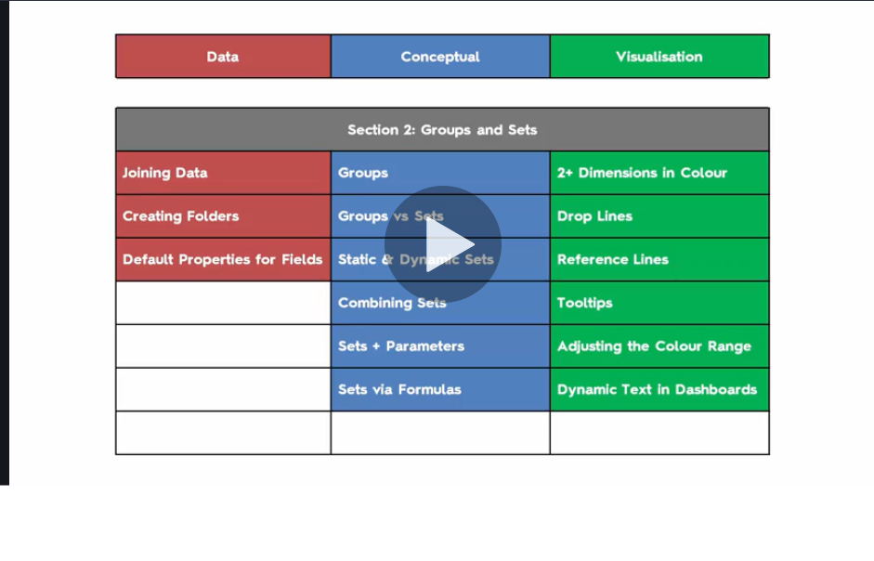

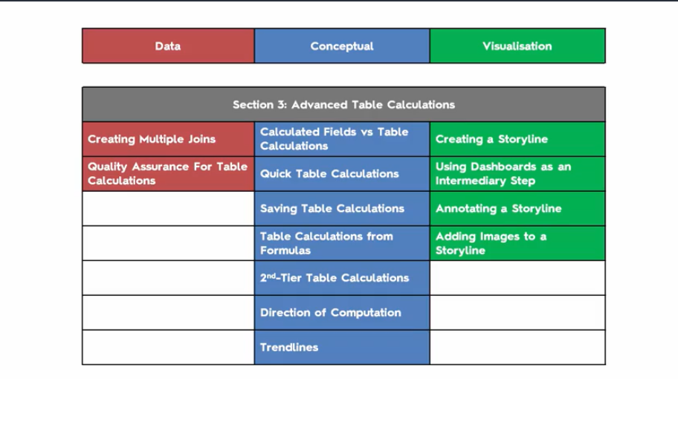

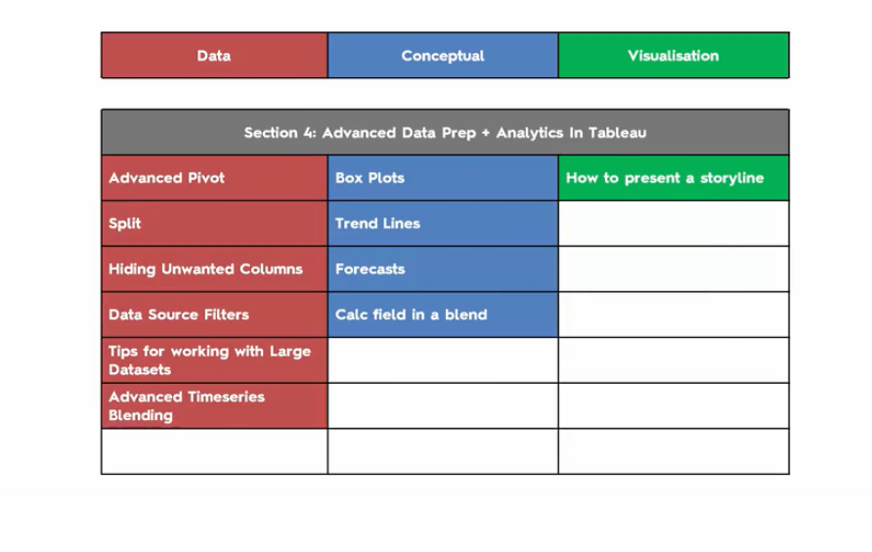

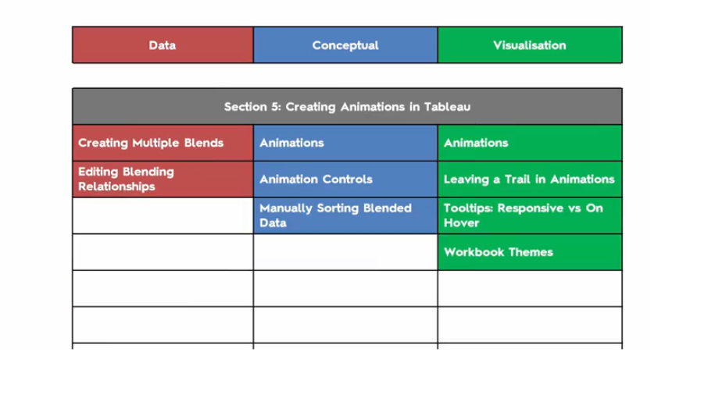

Advanced:

<https://www.udemy.com/certificate/UC-5b798b6b-c039-4c1c-b6ea-cc63185dd13b/>

<http://www.tableau.com/sites/default/files/media/which_chart_v6_final_0.pdf>

<https://www.interworks.com/blog/ccapitula/2014/08/04/tableau-essentials-chart-types-text-table>

<https://www.tableau.com/sites/default/files/whitepapers/which_chart_or_graph_is_right_for_youwp_1.pdf>